Model：SW-LZB5-002 Cup dispenser
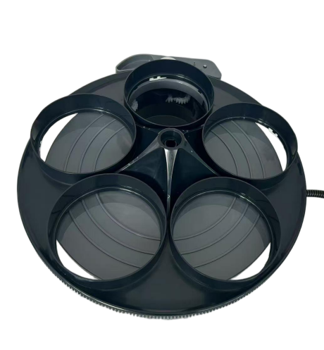

Cup dispenser:
Features: Small size, high reliability, low noise
Application：Vending machine, Coffee machine
Remarks: 5 holes cup dispense with control ,barrel and barrel cover



Model | Rated Voltage | No-load Current | No-load speed | Direction of rotation | Noise
SW-LZB5-002 | 24VDC | 0.08A Max | 4000Rpm | CCW/CW | ≤55dB (A)


