Model：SW-LZB1-007 (3) Cup dispenser
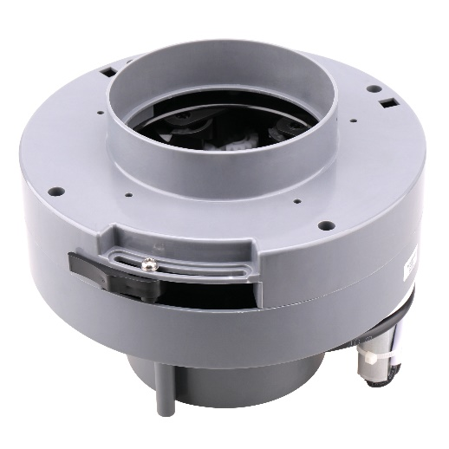

Cup dispenser:
Features: Small size, high reliability, low noise
Application：Vending machine, Coffee machine

Remarks: Available cup mouth diameter range from 60mm to 90mm



Model | Rated Voltage | No-load Current | No-load speed | Direction of rotation | Noise
SW-LZB1-007(3) | 24VDC | 0.12A Max | 4300Rpm | CCW | ≤65dB (A)


