Model：SW-VWLHG-007F Gearbox motor of vending machine

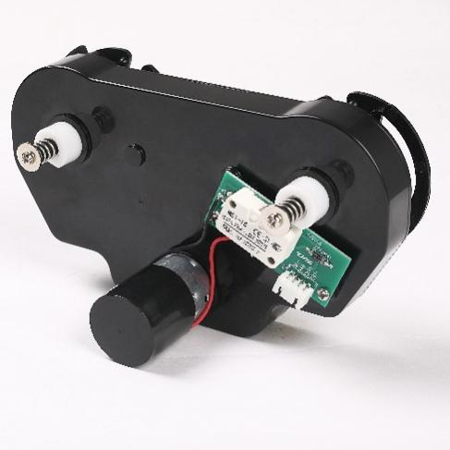

Gearbox motor of vending machine:
Features: Big output torque, high reliability, low noise
Application：Vending machine, Coffee machine



Model | Rated Voltage | No-load Current | No-load speed | Reduction ratio | Rated torque | Rated current | Rated speed | Max torque | Noise
SW-VWLHG-007F | 24VDC | 0.30A Max | 23.5Rpm | 1:418.5 | 1Kg.cm | 0.6A Max | 20Rpm | 100Kg.cm | 78dB (A)


