Model：SW-VWLHG-001F Gearbox motor of vending machine

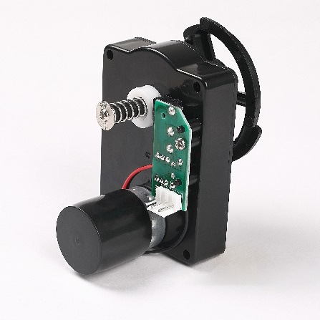


Gearbox motor of vending machine:
Features: Big output torque, high reliability, low noise
Application：Vending machine, Coffee machine



Model | Rated Voltage | No-load Current | No-load speed | Reduction ratio | Rated torque | Rated current | Rated speed | Max torque | Noise
SW-VWLHG-001F | 12VDC/  24VDC | 0.16A Max | 23.5Rpm | 1:418.5 | 1Kg.cm | 0.25A Max | 20Rpm | 40Kg.cm | 65dB (A)



