Model： SW-VHLF3-018A Gearbox motor of vending machine
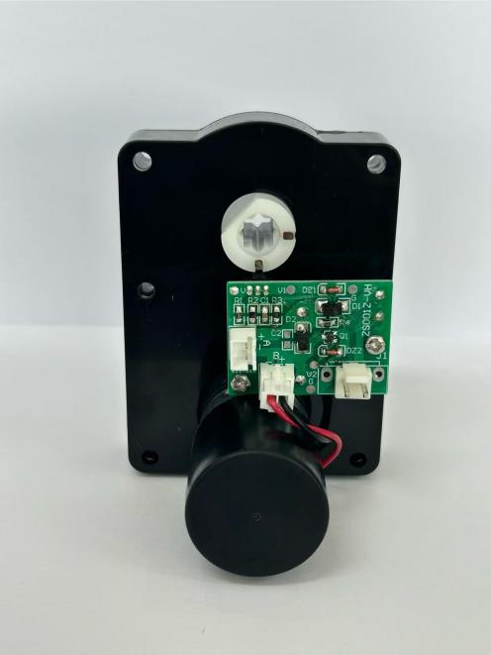

Gearbox motor of vending machine:
Features: Big output torque, high reliability, low noise
Application：Vending machine, Coffee machine



Model | Rated Voltage | No-load Current | No-load speed | Direction of rotation | Max torque | Noise
SW-VHLF3-018A | 24VDC | 0.16A Max | 23.5±3rpm | CCW | ≥40kg.f.cm | 65dB (A)


