Model：SW-VHLA2-002 Gearbox motor of vending machine

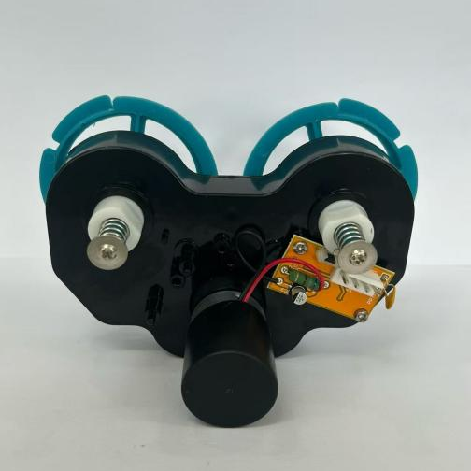
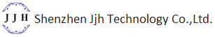
Gearbox motor of vending machine:
Features: Big output torque, high reliability, low noise
Application：Vending machine, Coffee machine



Model | Rated Voltage | No-load Current | No-load speed | Reduction ratio | Rated torque | Rated current | Rated speed | Max torque | Noise
SW-VHLA-002 | 24VDC | 0.16A Max | 23.5Rpm | 1:418.5 | 1Kg.cm | 0.25A Max | 20Rpm | 40Kg.cm | 65dB (A)

