Model： SW-C180S2-008C Gearbox motor of vending machine
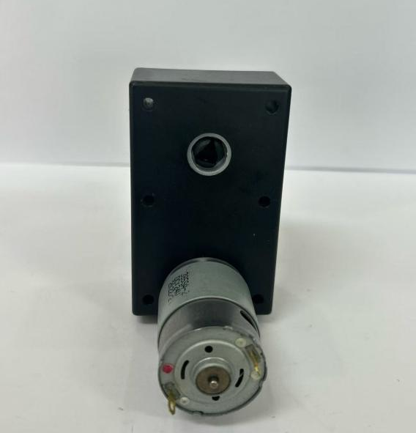

Gearbox motor of vending machine:
Features: Big output torque, high reliability, low noise
Application：Vending machine, Coffee machine



Model | Rated Voltage | No-load Current | No-load speed | Direction of rotation | Noise
SW-C180S2-008C | 24VDC | 0.25A Max | 180±5rpm | CCW/CW | 75dB (A)


