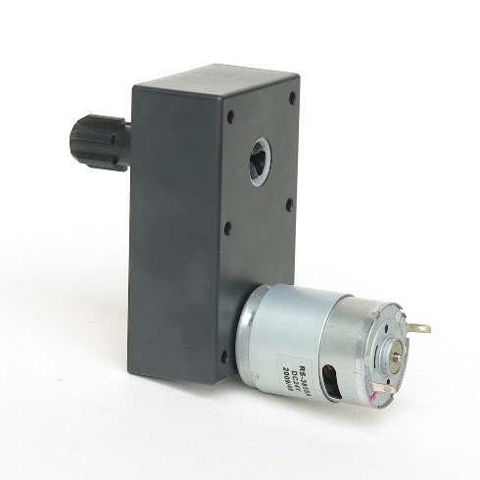
Model：SW-C130S2-004C Gearbox motor of vending machine

Gearbox motor of vending machine:
Features: Big output torque, high reliability, low noise
Application：Vending machine, Coffee machine



Model | Rated Voltage | No-load Current | No-load speed | Direction of rotation | Max torque | Noise
SW-C130S2-004C | 12VDC/24VDC | 0.15A Max | 30Rpm,50Rpm,80Rpm,  130Rpm,145Rpm | CCW/CW | 10Kg.cm, 7.5Kg.cm, 4.5Kg.cm,  2.8Kg.cm, 2.5Kg.cm | 65dB (A)


