Model： FAWN42055436 Gearbox motor of vending machine
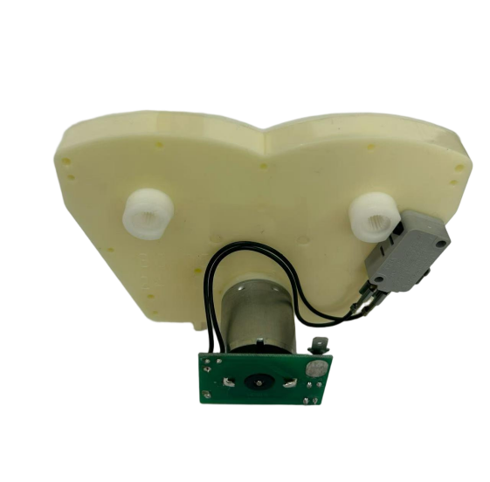

Gearbox motor of vending machine:
Features: Big output torque, high reliability, low noise
Application：Vending machine, Coffee machine



Model | Rated Voltage | No-load Current | No-load speed | Direction of rotation | Max torque | Noise
FAWN42055436 | 24VDC | 150mA Max | 17-24rpm | CCW | 13.67kg.cm | 70dB (A)


